**CS 122B Project 5 Report**

Team-88

Ye Yuan 49889946 | Lingzhe Kong 93985614

**Task 1:**

1. Connection Polling:

|  |  |  |
| --- | --- | --- |
| File Name | Line Number | Snapshot |
| _dashboard.jsp | 23 |  |
| BrowsePage.jsp | 16 |  |
| checkout.jsp | 14 |  |
| confirmation.jsp | 13 |  |
| insertMovie.jsp | 17 |  |
| insertStar.jsp | 12 |  |
| MoviePage.jsp | 14 |  |
| search.jsp | 11 |  |
| shoppingcart.jsp | 11 |  |
| StarPage.jsp | 13 |  |
| AndroidLogin.java | 39 |  |
| AndroidSearch.java | 45 |  |
| AutoComplete.java | 64 |  |
| EmployeeLoginServlet.java | 55 |  |
| LoginServlet.java | 55 |  |

**How connection polling was implemented:**

We removed the codes of username, password and URL, as well as the code that we used to make JDBC connection with. Then we implemented the codes from the given example, which will get information about JDBC from “META-INF/content.xml”.

1. Prepared statements:

|  |  |  |
| --- | --- | --- |
| File Name | Line Number | Snapshot |
| _dashboard.jsp | 42 |  |
| BrowsePage.jsp | 35 |  |
| checkout.jsp | 47 |  |
| confirmation.jsp | 33 |  |
| insertMovie.jsp | 39 |  |
| insertStar.jsp | 43 |  |
| MoviePage.jsp | 34 |  |
| search.jsp | 67 |  |
| shoppingcart.jsp | 81 |  |
| StarPage.jsp | 33 |  |
| AndroidLogin.java | 61 |  |
| AndroidSearch.java | 67 |  |
| AutoComplete.java | 97 |  |
| EmployeeLoginServlet.java | 76 |  |
| LoginServlet.java | 77 |  |

**How prepared statement was implemented?**

We use prepared statements to replace the statements that created by connection.createStatement(), and use setString()/setInt() to fill in the “?”in the prepared statement to make it be a full search query.

**Task 2**

* Address of AWS and Google instances

AWS instance 1: 52.14.246.47

Instance 2 (master): 18.221.120.129

Instance 3 (slave): 18.219.152.237

Google cloud platform: 35.185.89.240

* Have you verified that they are accessible? Does Fablix site get opened both on Google’s 80 port and AWS’ 8080 port?

YES

* Explain how connection pooling works with two backend SQL (in your code)?
  + File name, line numbers as in Github

In /project5/WebContent/META-INF/context.xml

Line 15- line 23

In /project5/WebContent/WEB-INF/web.xml

Line 8 – line 23

We make two datasource one is TestDB and one is InsertDB and store the user name, password, url of mysql in it.

* + Snapshots

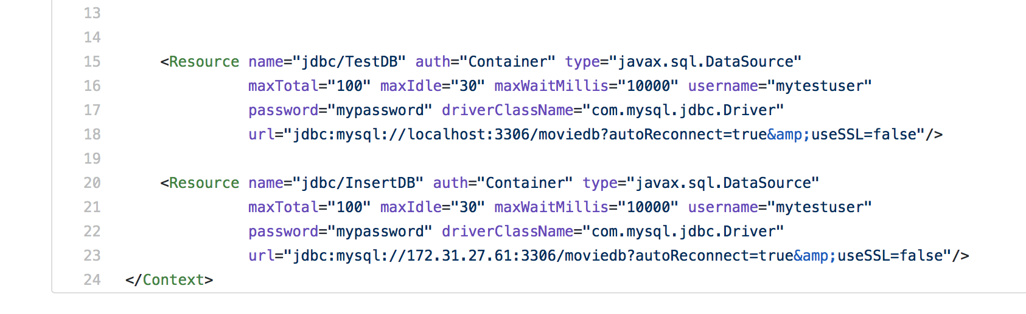

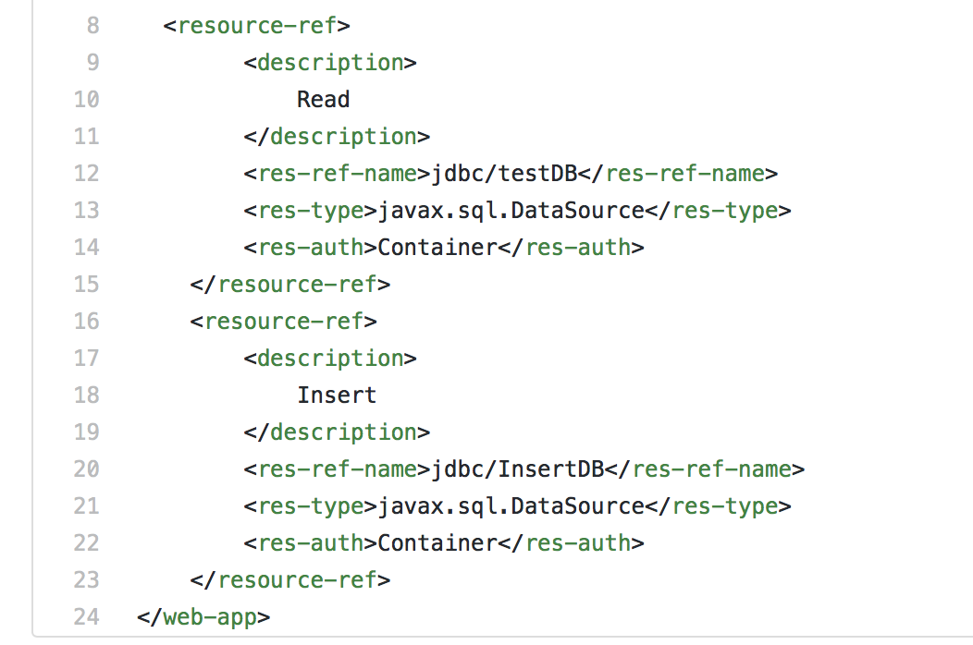

* How read/write requests were routed?
  + File name, line numbers as in Github
* In /project5/WebContent/META-INF/context.xml

We let all the read request get connection with datasource jdbc/TestDB which has url “localhost”

And then , we let all the insert request get connection with datasource jdbc/InsertDB which has the internal IP address of the master instance, so in this case ,all the write requests will go to master.

* Snapshots



Notice: we let all the insert servlets use jdbc/InsertDB to get connection, you can see the screenshots from above(Task 1 screenshots)

**Task 3**

* Have you uploaded the log files to Github? Where is it located?

It is in the folder called “report”. There are 9 cases logs in this folder.

* Have you uploaded the HTML file (with all sections including analysis, written up) to Github? Where is it located?

Yes, it is in the “report” folder.

* Have you uploaded the script  to Github? Where is it located?

Yes, it is in the “report” folder and each subfolder as well.

* Have you uploaded the WAR file and README  to Github? Where is it located?

Yes, They are in the root folder.